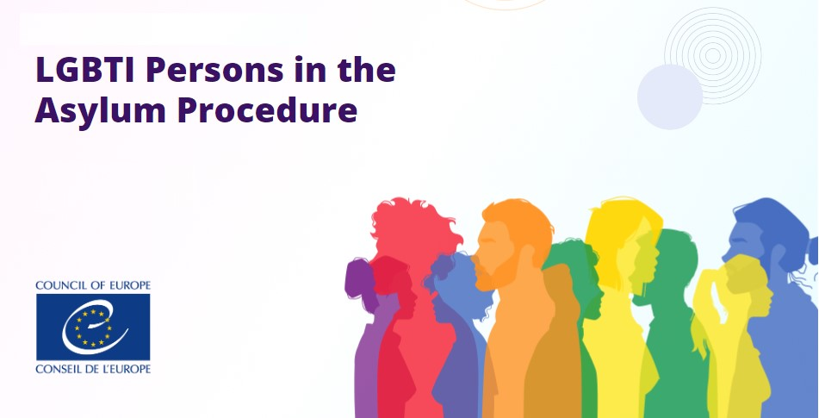
LGBTI Persons in the Asylum Procedure  HELP ONLINE COURSE | Duration: 3 hours  Available for free on the CoE HELP e-learning platform  Statement of Accomplishment  START COURSE

 | Council of Europe  Human Rights Education for Legal Professionals (HELP) Programme | 2023

Background
In many states around the world, LGBTI persons are subject to serious human rights violations on account of their real or perceived sexual orientation, gender identity or expression and sex characteristics (SOGIESC), particularly when these do not conform to dominant social and cultural norms. Persecution, including discrimination from both State and non-State actors force LGBTI persons to flee their countries of origin or places of habitual residence in search of a safe environment in which they can freely express their SOGIESC.
Often, LGBTI persons seeking international protection experience barriers to the adjudication of their asylum claims. It follows from the Summary Conclusions of the 2021 Global Roundtable on Protection and Solutions for LGBTIQ+ People in Forced Displacement that “some caseworkers, lawyers and asylum adjudicators lack a sufficiently nuanced understanding of what sexual orientation, gender identity, gender expression and sex characteristics entail. Notable challenges in the legal protection of LGBTIQ+ asylum seekers include evidentiary burdens in asylum claims; challenges in satisfying criteria for well-founded fear and/or membership of a particular social group; jurisprudential and credibility challenges; and implicit biases and/or stereotypes held by caseworkers, lawyers and asylum adjudicators.”
According to the second comprehensive review of the implementation of the CoE Recommendation CM/Rec (2010)5 to member states on measures to combat discrimination based on sexual orientation or gender identity, the training of asylum officials remains a key issue. The CoE Commissioner for Human Rights, Dunja Mijatovic, expressed concern regarding the protection of LGBTI asylum seekers in Europe, and found that there is an urgent need for practical guidance and training for all those involved in the asylum procedure. In addition, the need to improve the training of decision-makers dealing with asylum claims by LGBTI people was also highlighted by the European Commission in its LGBTIQ Strategy 2020-2025 and by UNHCR and the United Nations Independent Expert on Protection Against Violence and Discrimination Based on Sexual Orientation and Gender Identity in their Summary Conclusions of the 2021 Global Roundtable on Protection and Solutions for LGBTIQ+ People in Forced Displacement.
To increase the capacity of legal professionals dealing with asylum claims based on SOGIESC, through the HELP module on LGBTI Persons in the Asylum Procedure, professionals will learn about the key concepts and stereotypes or incorrect assumptions in adjudicating cases involving LGBTI persons, international standards and how they have been applied by national asylum authorities and courts across Europe, as well as relevant case-law. By the end of the course, they will have a better understanding of the rights of LGBTI asylum-seekers in different stages of their asylum-claim, of the substantive and procedural aspects. Consequently, they will be better equipped to assess asylum claims based on SOGIESC grounds and to apply a human rights approach throughout the decision-making process.
Course outline
The course consists of 4 modules:
1 | Introduction  - How to navigate through the course  - By whom? / Why? / For whom?  - Structure of the course / Learning objectives  - Terminology
2 | Legal framework  - Universal standards  - European standards (Council of Europe / European Union)
3 | The rights of LGBTI persons in the asylum context  - Vulnerability and LGBTI asylum-seekers  - Detention / Reception conditions  - Respect for family unit  - Recognition of gender identity
4 | Substantive and procedural aspects related to the asylum application  - Entry and first contact  - Application  - Interview(s)  - Assessment and decision-making

Target audience
This free on-line course is addressed to:
- legal professionals (judges, senior court staff, lawyers, prosecutors)
- asylum authorities
- other actors of the asylum procedure (border guards, interpreters, staff from detention/ reception facilities)
It can be also useful for law enforcement authorities, equality bodies personnel and other persons working in the field of asylum.
About the course
The course has been developed within the CoE Project Promoting Human Rights and Equality for LGBTI Persons III. It also benefitted from the expertise of representatives of the Registry of the European Court of Human Rights, the CoE SOGI Unit, the Office of the CoE Secretary General’s Representative on migration and refugees, the EU Agency for Asylum, as well as several civil society organisations.
It can be taken as a standalone course or added to the existent HELP courses related to the topics of antidiscrimination and asylum.
How to access the HELP online course
The course is freely available in self-learning format on the CoE HELP e-learning platform. The overall length of the online course is approximatively 3 hours and those who complete it in self-learning format can obtain an electronic ‘Statement of accomplishment’.
To access the course, you need to have a HELP account. If you haven’t created one yet, you can sign up here, it only takes 2 minutes.

