Concept Note
« EU Support for Internal Market »
CRIS 2023/ 445-054

BACKGROUND INFORMATION AND METHODOLOGICAL DETAILS

The project EU Support for Internal Market (EU4IM) aims to promote the integration of the Serbian market into the internal market of the EU through the improvement of the efficiency of Serbian institutional agents and its alignment of EU acquis on internal market.

Against this background, the support to the judiciary to update and increase the technical capacities to deal with complex cases is a priority for Serbia, as highlighted in the Serbian 2024 Report drafted by the European Commission. This project specifically deals with the topics of Competition and Intellectual Property Rights.

A mission by a EU senior judge was carried out to elaborate the training needs assessment in order to draft an efficient and sustainable training strategy that has been validated with the competent Courts and the Judicial Academy.

The approach agreed with the Serbian Judicial Academy consists of conducting a Training of trainers in Competition and Intellectual Property Rights.

In that regard, the Courts will select a pool of Serbian judges, mainly from the Administrative and Commercial Court, who will attend the complete training itinerary, composed of 8 seminars. In addition, an ad hoc seminar for criminal infringements will be organized for the Criminal Court and Administrative Court, the Public Prosecution Office, and other relevant administrations. In Annex I, the main topics of the seminars are provided.

In addition to the pool of judges who will follow the complete itinerary, relevant Courts will be invited to complement the number of participants for each seminar, selecting other interested judges only in the specific subject of that specific seminar.

The training sessions, which will run from April 2025 (the first seminar is proposed for 10th and 11th April 2025) until the project's estimated date of finalization in November 2026, will be designed as workshops based in case studies, where EU practical cases, the EU relevant jurisprudence and the possible interaction with the national legislation and jurisprudence will be discussed. Table I includes an overview of the seminars, including tentative dates, topics and main participants

The duration of each of the seminars will last a day and a half in Belgrade. Annex II contains an example of the generic workshop’s organization.

The project EU4IM is engaging EU specialized judges in Competition and Intellectual Property to act as trainers in this program.

With the aim of making the most of these seminars, being more practical, dynamic and interactive, the trainers, who will be EU judges specialize in Competition and Intellectual Property, will ask for collaboration of the participants before the training sessions (2 weeks before, approximately). In Annex III, the minimum requested profile of the trainers is provided.

The collaboration between trainers and participants may consist of the delivery of information from national cases that can be related to the topics of the sessions, including some questions, reflections etc. Also, some complementary topics related to the ones proposed in the Annex I can be proposed to the trainers

In addition, there is the possibility for the participants to act as rapporteur of the main aspects of the national legislation and the current interaction with the EU legislation, which would include a short presentation to the trainers and the rest of participants.

Logistics, financial and other complementary details are included in Annex V.

Additional information
Table 1. List of training itineraries, including tentative dates, topics and main participants 4
Annex I. List of tentative content to guide the content of the training sessions 5
Annex II. Tentative proposal for workshop configuration 12
Annex IV. Trainer of Trainers Profile 14
Annex V. Financial, logistical and other complementary details 15

Table 1. List of training itineraries, including tentative dates, topics and main participants

ITINERARY | Tentative Date | Topics | Main Participants
ITINERARY 1 | 10th and 11th April 2025 | EU Trademarks and Community Designs | Commercial Courts  Administrative Courts  Civil Courts
ITINERARY 2 | June 2025 | Introduction to EU Competition Law. Digital Markets
ITINERARY 3 | September 2025 | EU Competition Public Enforcement, article 101 TFEU
ITINERARY 4 | November 2025 | EU Geographical Indications
ITINERARY 5 | February 2026 | EU Competition Public Enforcement, article 102 TFEU
ITINERARY 6 | April 2026 | EU Patent Law
ITINERARY 7 | June 2026 | EU Competition Private Enforcement
ITINERARY 8 | September 2026 | EU Copyright
ITINERARY 9 | November 2026 | EU Criminal Law in the field of IP | Criminal Courts, Public Prosecution Office, Administrative Court

Annex I. List of tentative content to guide the content of the training sessions


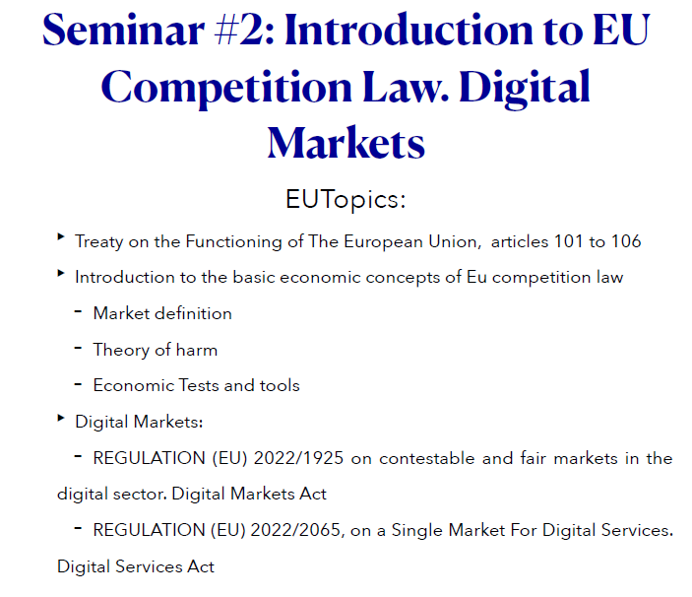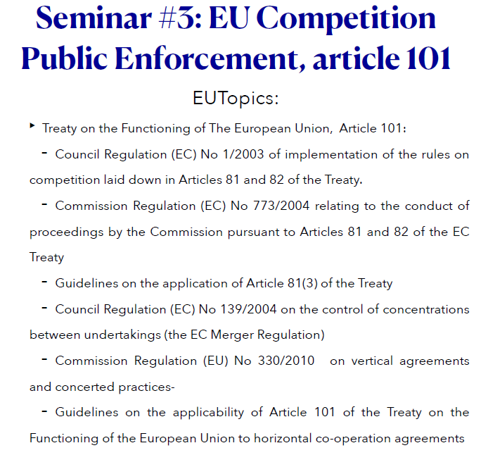


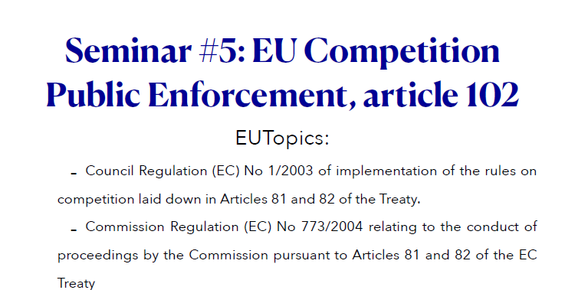

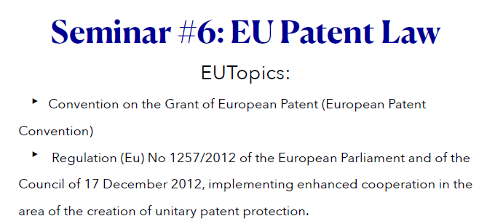
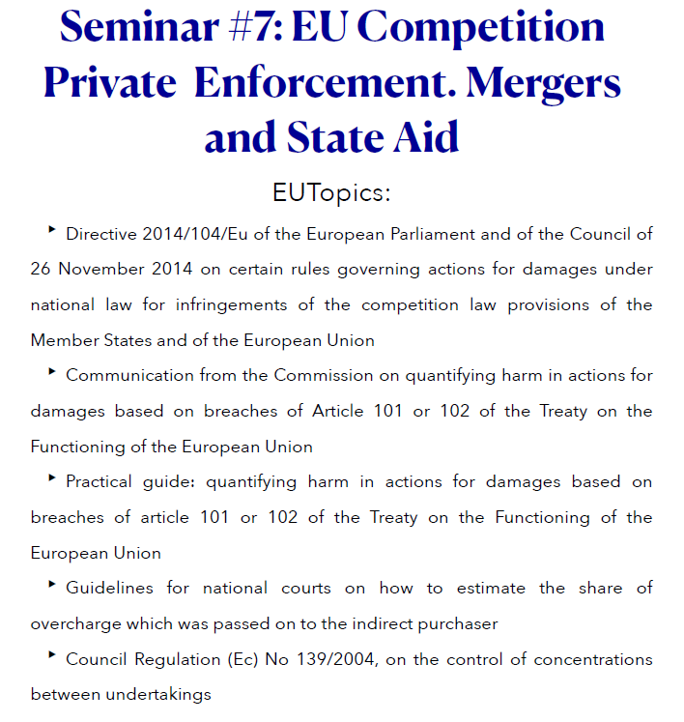



Annex II. Tentative proposal for workshop configuration

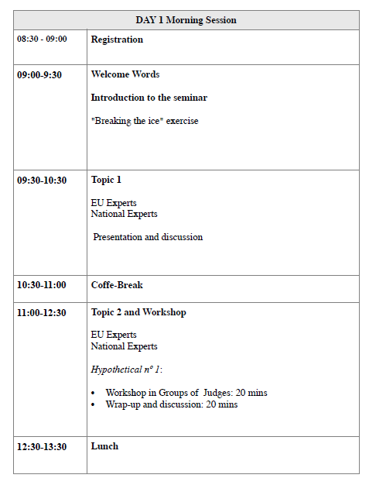
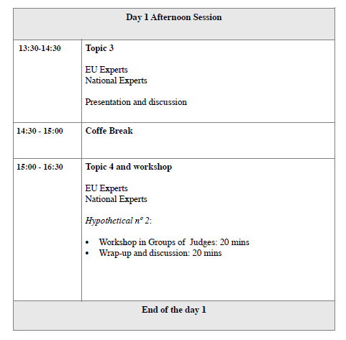

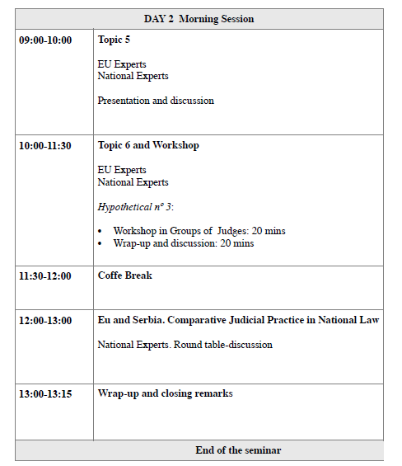

Annex IV. Trainer of Trainers Profile

QUALIFICATIONS AND SKILLS
- Advanced English (min. C1)
- Good communication and reporting skills.
GENERAL PROFESSIONAL EXPERIENCE
- A minimum of 5 years of proven work experience, preferably 8 years, as a Judge
- For the Itinerary 9, the required profile is judge or prosecutor, prioritising the selection of prosecutors.
- For the rest of the itineraries (1 to 8) the required profile is judge.
- A minimum of 5 years of proven work experience, preferably 8 years, in Judicial Training and/or training of trainers

SPECIFIC PROFESSIONAL EXPERIENCE
- Demonstrated work experience in delivering training for judges

- Extensive professional expertise in dealing with Intellectual Property Rights and Competition) cases (min. 5 years) in the topics of the seminars.
ADDITIONAL CRITERIA
- Previous experience/s in international Projects in the Balkans will be an advantage.
- Previous experience/s with judicial entities in Serbia and/or with the Judicial Academy of Serbia will be an advantage.
- Knowledge of Serbo-Croatian will be an advantage.

Annex V. Financial, logistical and other complementary details

ACTIVITY | Training of trainers for Serbian Judiciary: EU Competition and IP Law
PARTNERS INSTITUTIONS | Commercial Courts (first and second instance), Administrative Courts and other relevant Courts (e.g. Civil Courts)
OTHER RELEVANT INSTITUTIONS | Judicial Academy, Intellectual Property Office, Commission for Protection of Competition
ACTIVITY TYPE | Training/Workshop
CONTRIBUTION TO OUTPUT INDICATOR NUM | OP.2.1. Number of state institutions and non-state actors supported by the intervention  OP.2.2 Number of people trained by EU4IM
DELIVERABLES  (if applicable) | - Didactic materials with the content of the sessions, including the presentations, EU and Serbian cases (if applicable) that will be discussed, and the practical exercises used during the sessions  - Mission report summarizing the participation in the seminar, main findings, conclusions, and possible suggestions (topics, orientation, new actions) that could contribute to further improve the technical capacity of the Serbian judiciary.
ESTIMATED TIME OF DEDICATION | 5 working days per Itinerary and Trainer
TIME FRAME | See table 1 for the tentative dates  The timeframe structure consists of 2 remote working days (one prior to the training and another within one week after the training) and 3 presential working days in Belgrade
PERFORMANCE MODALITY | 1 remote working day (preparation of the agenda with the feedback of the Serbian institutions and finalization of deliverables): 250 € /day  2-3 field working days in Belgrade: 450€/day
DESK WORK | Preparation of the mission, compiling both technical and contextual information to adapt the training, including needs and main challenges. Draft of the materials.
FIELD WORK | Delivery of the presentations  Preparation of practical cases  Foster participation for discussion of the cases
LOGISTICS | EU4IM project covers all travel costs and the per diems (165 € per day) related to experts’ mobilization.

