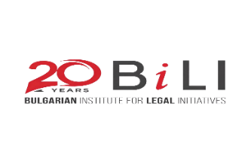
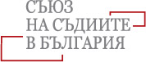
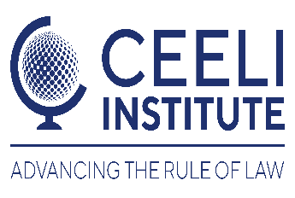



AGENDA
Judicial Ethics and Integrity Forum
June 25, 2026
Location: Hyatt Regency Hotel, Sofia, Bulgaria
Vasil Levski Conference Room

09:00 – 09:30 Registration

09:30 – 10:00 Opening Remarks
John C. Hanley
Central Europe Anti-Corruption Resident Legal Advisor
U.S. Department of Justice
Overseas Prosecutorial Development, Assistance, and Training (OPDAT)
U.S. Embassy Sofia

Marcela Entlichova
Program Manager
CEELI Institute

Judge Galina Zaharova (TBC)
President
Supreme Court of Cassation

Bilyana Gyaourova-Wegertseder
Executive Director
Bulgarian Institute for Legal Initiatives

Miglena Tacheva (TBC)
Director
National Institute of Justice

I. Judicial Ethics and Integrity Segment

10:00 – 10:20 Judicial Ethics and Integrity in the U.S.: Lessons from the U.S. Federal Judiciary
Judge David Campbell
United States District Court
District of Arizona

10:20 – 10:40 Judicial Ethics in Practice: Current Challenges Facing Bulgarian Judges
Judge (TBD)
Bulgarian Judges Association (TBD)

10:40 – 11:00 Bulgarian Judiciary: Corruption and Integrity Issues
Iva Pushkarova
Professor
Sofia University

11:00 – 11:30 Discussion and Q&A Session

11:30 – 12:00 Coffee Break

II. Vetting and Alternatives to Vetting Segment

12:00 – 12:20 Judicial Vetting in Europe: Lessons Learned from Recent Reform Efforts
Judge Greg Borkowski
International Legal Expert
CEELI Editorial Board Member

12:20 – 12:40 Alternatives to Extraordinary Judicial Vetting
Judge Atanas Atanasov
Sofia Appellate Court
President, Bulgarian Judges Association

12:40 – 13:10 Discussion and Q&A Session

13:10 – 14:10 Lunch

14:10 – 14:30 Disciplinary Liability of Judges and Prosecutors: Necessary Reforms
Judge Atanaska Disheva
Member
Bulgarian Supreme Judicial Council

III. Judicial Communication Segment

14:30 – 14:50 Judicial Communication with the Public and the Media – The CEELI Guidelines
Marcela Entlichova
Program Manager
CEELI Institute

14:50 – 15:10 Judicial Communication with the Public and the Media – The U.S. Experience
Judge David Campbell
United States District Court
District of Arizona

15:10 – 15:30 Judicial Communication with the Public and the Media – The European Experience
Judge Greg Borkowski
International Legal Expert
CEELI Editorial Board Member

15:30 – 16:00 Discussion and Q&A Session

16:00 – 16:10 Closing Remarks and Evaluation

16:10 – 17:30 No Host Happy Hour
Location: The Scene, Hyatt Regency Rooftop bar
After the program, we will gather at the rooftop bar of the Hyatt Regency Hotel for some casual drinks between counterparts. While we are unable to pay for this portion of the event, we will provide good cheer and would be thrilled to get the chance to chat.

